HAT
Rational Functions
Review Packet

Perform the Operation and Simplify:

1. 2.

3. 4.

Solve:

5. 6.

7. List the following information for :
Domain:___________________
Range:____________________
Vertical asymptotes:_______________
Horizontal asymptotes (if any exist):_________________
Oblique asymptotes (if any exist):___________________
Zeros:__________________
y-intercept:___________________

8. Graph (list all key information):
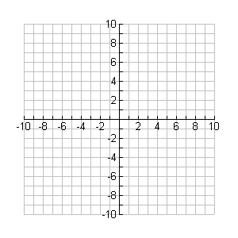
9. Graph (list all key information):

10. Write the equation of the following graph:

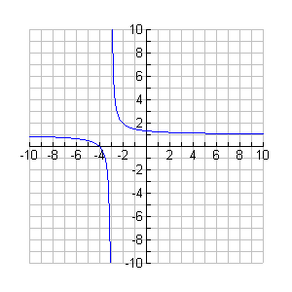

11. I can paint 5 rooms in my house in 16 hours while my husband can paint 3 rooms in 11 hours. How long would it take to paint 4 rooms if we worked together?

Be able to:

Give Domain of a rational expression
Simplify rational expressions
Add, subtract, multiply, and divide rational expressions
Solve rational equations
Match rational equations with their graph
List key points of a rational graph (asymptotes, holes, intercepts, zeros)
Graph rational functions
Solve application problem with rational functions

